**Homework 2**Lesson: SMLStudent Name: Zhao EnpingClass: G1

1. **intercept coefficient (alpha) and slope coefficient (beta) for each of the ten industry portfolios.**

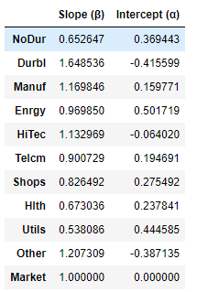

Economic significance:

The intercept (α) represents the expected return of portfolio return when market portfolio’s return is equal to 0.00%. the slope (β) represents the linear correlation between individual portfolio with market portfolio. It is also a measure of sensitivity of the portfolio return against the market portfolio. Generally, investor should look for portfolio that has a higher α. And invest in portfolio has higher β when during a bull market and invest in portfolio has a lower β during a bear market

1. Derive the slope and intercept of SML by Regress the mean monthly returns of the ten industry portfolios and the market portfolio on the corresponding betas

* Slope (α) = -0.18546745836573256
* Intercept (β) = 1.0327683682657058

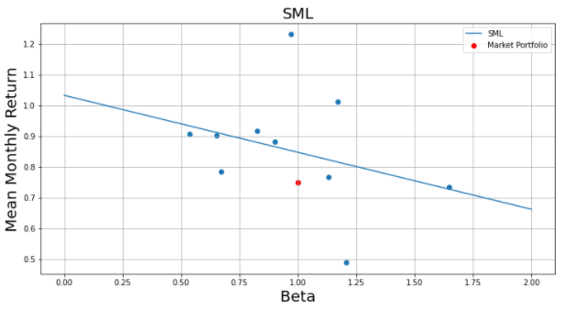

Economic significance:

The security market line(SML) is commonly used by investors in determining whether the security offers a favorable expected return compared to its level of risk. When a security is plotted on the SML chart, if it appears above the SML, it is considered undervalued because the position on the chart indicates that the security offers a greater return against its inherent risk. Conversely, if the security plots below the SML, it is considered overvalued in price because the expected return does not overcome the inherent risk.

**Appendix:**

